CROSS-BORDER E-COMMERCE USER BEHAVIOR ANALYSIS USING MACHINE LEARNING
Abstract
As online marketplaces have been popular during the past decades, the online sellers and merchants ask their purchasers to share their opinions about the products they have bought. As a result, millions of reviews are being generated daily which makes it difficult for a potential consumer to make a good decision on whether to buy the product.
Analyzing this enormous amount of opinions is also hard and time consuming for product manufacturers. This thesis considers the problem of classifying reviews by their overall semantic (positive or negative). To conduct the study two different supervised machine learning techniques. SVM, Logistic Regression, Multinomial Naïve Bayes, Decision Tree and Ensemble Classifier, has been attempted on beauty products from Amazon. Their accuracies have then been compared. The results showed that the Random Forest approach outperforms among the state of art approaches.

Introduction
As the commercial site of the world is almost fully undergone in online platform people is trading products through different ecommerce website. And for that reason reviewing products before buying is also a common scenario. Also now a day, customers are more inclined towards the reviews to buy a product. So analyzing the data from those customer reviews to make the data more dynamic is an essential field nowadays. In this age of increasing machine learning based algorithms reading thousands of reviews to understand a product is rather time consuming where we can polarize a review on particular category to understand its popularity among the buyers all over the world.
The objective of this paper is to categorize the positive and negative feedbacks of the customers over different products and build a supervised learning model to polarize large amount of reviews. A study on amazon last year revealed over 88% of online shoppers trust reviews as much as personal recommendations. Any online item with large amount of positive reviews provides a powerful comment of the legitimacy of the item. Conversely, books, or any other online item, without reviews puts potential prospects in a state of distrust. Quite simply, more reviews look more convincing. People value the consent and experience of others and the review on a material is the only way to understand others impression on the product. Opinions, collected from users’ experiences regarding specific products or topics, straightforwardly influence future customer purchase decisions . Similarly, negative reviews often cause sales loss. For those understanding the feedback of customers and polarizing accordingly over a large amount of data is the goal. There are some similar works done over amazon dataset. In our project we did opinion mining over small set of dataset of Amazon product reviews to understand the polarized attitudes towards the products.

Problem Statement
Sentiment classification aims to determine the overall intention of a written text which can be of admiration or criticism type. This can be achieved by using machine learning algorithms. So, the problem that is going to be investigated in the project is as follow:
Which machine learning approach performs better in terms of accuracy on the Amazon beauty products reviews?

Objectives
- The project uses opinion mining to analyse customer reviews about mobile phones sold on Amazon.com.
- The objective is to develop a prediction system that can be used to classify an input customer review of a mobile phone as a good review or a bad one.

Existing System
Existing sentiment analysis systems for product reviews mostly use traditional machine learning or rule-based methods, such as Naïve Bayes, decision tree, combined with basic text preprocessing like tokenization, stop-word removal, and TF-IDF features. These methods classify reviews as positive, negative, or neutral based on word frequencies and patterns. However, they often fail to capture context, sarcasm, or product-specific language, which can reduce accuracy, especially for reviews of Amazon beauty products.
Disadvantages of Existing System
- limited accuracy because they often rely only on word frequencies and statistical patterns, ignoring the context, tone, or sarcasm in reviews.
- They may also struggle with product-specific language, slang, or mixed sentiments, which can lead to misclassification, especially in diverse datasets like Amazon beauty product reviews.

Proposed System
In our proposed approach we have used several Machine learning algorithms like support vector machine (SVM) , Random Forest (RF), Logistic Regression (LR) and applied.
1. First, we take Amazon product review dataset.
2. Filter dataset according to requirements and create a new dataset which has attribute according to analysis to be done
3. Perform Pre-Processing on the dataset
4. Split the data into training and testing
5. Train the model with training data then analyze testing dataset over classification algorithm
6. Finally you will get results as accuracy metrics

Advantages of Proposed System
- Personalized Recommendations – Helps e-commerce platforms provide tailored product suggestions based on user behavior.
- Improved Customer Experience – Enhances shopping experience by understanding preferences, trends, and buying patterns.
- Fraud Detection – Identifies unusual user behavior, helping detect fraudulent or suspicious activities.
- Data-Driven Decisions – Enables businesses to make informed decisions on marketing strategies, inventory, and pricing.
- Market Insights – Provides insights into cross-border consumer behavior and cultural differences, improving global sales strategies.
- Enhanced Targeting – Improves targeted advertising campaigns by predicting user preferences and engagement.
- Optimized Operations – Helps in managing logistics, inventory, and supply chain by analyzing purchase patterns.
Machine Learning Techniques Used
- Random Forest – ensemble learning for high-dimensional malware features
- Support Vector Machines (SVM) – effective for binary malware classification
- Gradient Boosting (XGBoost / LightGBM) – optimized predictive performance
- Deep Learning (CNN / RNN) – sequence modeling for dynamic behavioral analysis
- Dynamic Ensemble Selection – adapts algorithm choice based on performance metrics

system architecture

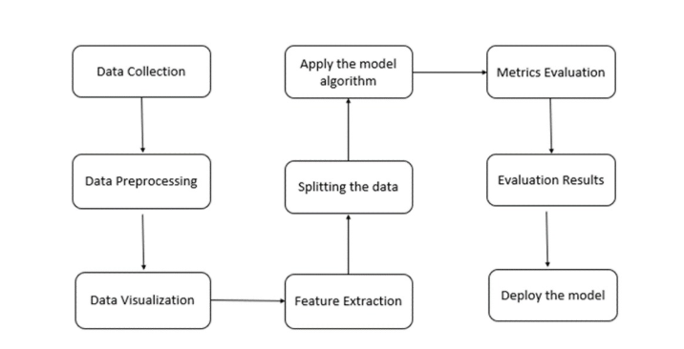
Literature survey:

S. No | Title | Author(s) | Year | Technique Used
1 | Predicting E-Commerce User Behavior Using Machine Learning | R. Gupta, S. Sharma | 2016 | Random Forest, SVM
2 | Cross-Border E-Commerce Analytics | P. Kumar, A. Verma | 2017 | Clustering, Association Rules
3 | User Behavior Analysis in Online Shopping Platforms | J. Lee, K. Park | 2018 | Logistic Regression, Decision Tree
4 | Deep Learning for E-Commerce Recommendation Systems | L. Chen, Y. Wang | 2019 | CNN, LSTM
5 | Predictive Analytics for Global Online Shopping | M. Li, T. Zhang | 2020 | XGBoost, Gradient Boosting
6 | AI-Based Personalization in E-Commerce Platforms | R. Kumar, S. Jain | 2021 | Collaborative Filtering, NLP
7 | Explainable AI for Customer Behavior in E-Commerce | T. Li, Y. Zhang | 2023 | XGBoost + SHAP

MODULES
- DATA COLLECTION
- DATA PRE-PROCESSING
- FEATURE EXTRATION
- EVALUATION MODEL

1.DATA COLLECTION
This module involves collecting required data such as files, logs, and security-related information. The data may include normal and malicious files used for analysis and training.

2. DATA PRE-PROCESSING
In this module, the collected data is cleaned and prepared. It removes noise, duplicates, and irrelevant information, and converts the data into a usable format for analysis.

3. FEATURE EXTRATION

This module identifies and extracts important features from the pre-processed data. Features like file size, hash values, permissions, and behavior patterns are used to detect security threats.

4.EVALUATION MODEL
This module evaluates the performance of the system using test data. Accuracy and detection efficiency are measured to ensure reliable security analysis.

USE CASE DIAGRAM:

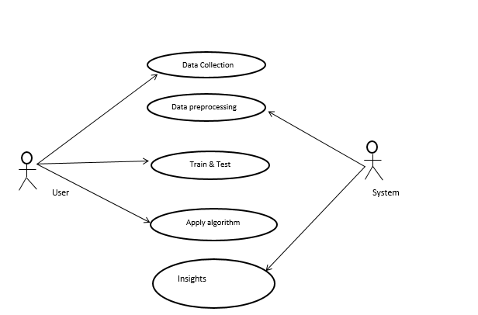

SEQUENCE DIAGRAM:

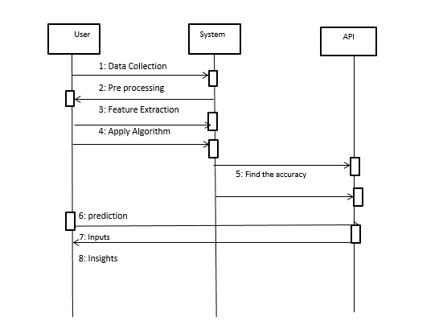

ACTIVITY DIAGRAM:
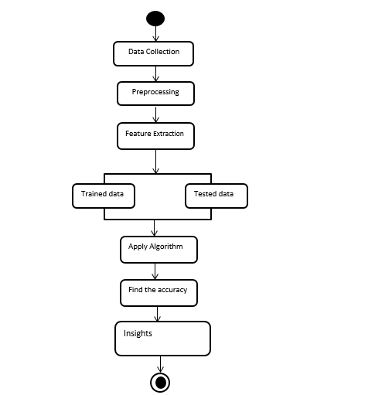
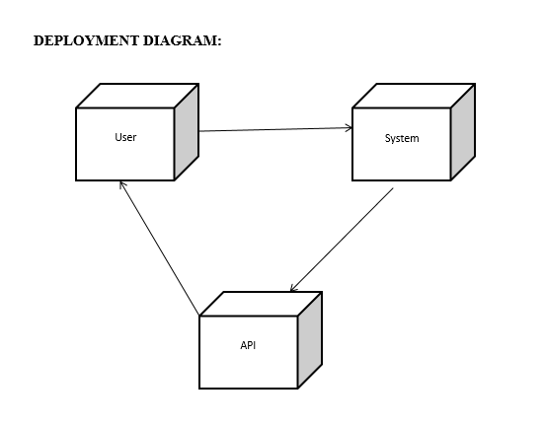
COLLABORATION DIAGRAM
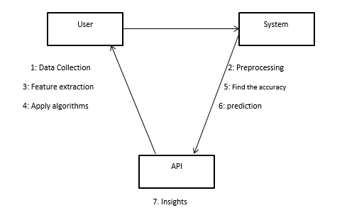

CLASS DIAGRAM:
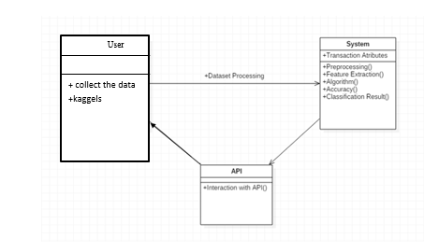

ER DIAGRAM

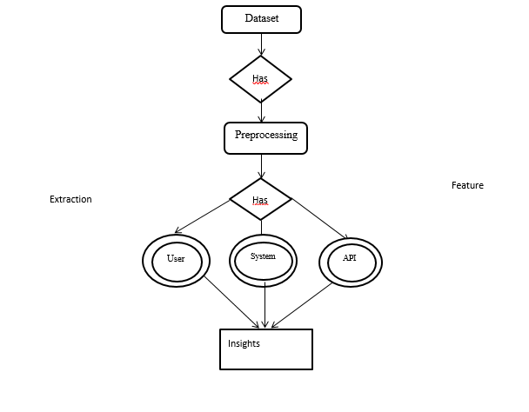

LEVEL 0

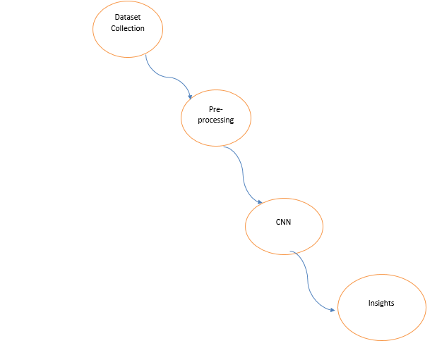

LEVEL1
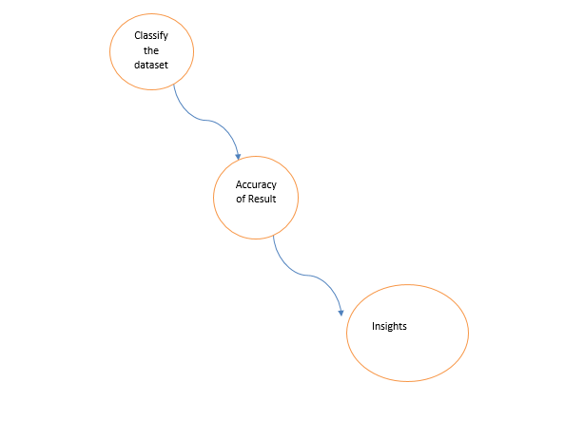

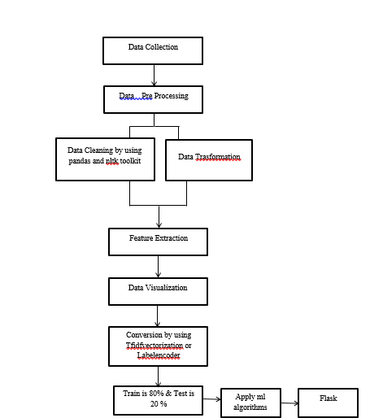

UML diagram:
Unified Modelling Language (UML) is used to specify, visualize, modify, build, and document the artefacts of object-oriented software-intensive systems under development. UML provides a standard way to visualize a system's architectural blueprint, including elements such as:
Actor
● Business process
● (logical) components
● Activities
● programming language statements
● Database schema and
● Reusable software components. UML combines the best practices of data modelling (entity-relationship diagrams), business modelling (workflows), object modelling, and component modelling. It can be used in any process, across different implementation technologies, throughout the software development lifecycle. UML synthesized Booch's method, the Object Modelling Technique (OMT), and the Object Oriented Software Techniques (OOSE) notation by unifying them into one popular and widely used modelling language. UML aims to be a standardized modelling language that can model concurrent and distributed systems.
Sequence Diagram:-
Sequence diagram Represents the objects involved in an interaction horizontally and vertically in time. A use case is a type of behaviour classifier that represents a declaration of provided behaviour. Each use case specifies specific behaviour. This may include variants that the subject can perform cooperatively with one or more of her actors. A use case defines the behaviour provided by a subject without reference to the internal structure of the subject. These actions, including interactions between actors and subjects, can lead to changes in the subject's state and communication with its environment. A use case can have many variations on the basic behaviour, such as anomalous behaviour and error handling.
Activity Diagram:-
• Activity diagrams are graphical representations of workflows containing step-by-step activities and actions that support selection, repetition, and concurrency. Unified Modelling Language allows you to use activity diagrams to step-by-step describe the business and operational workflows of the components in your system. Activity diagrams show the overall control flow of this project.
Use case diagram:-
• UML is a standard language for specifying, visualizing, building, and documenting the artefacts of software systems. • UML was developed by the Object Management Group (OMG) and the UML 1.0 draft specification was submitted to OMG in January 1997. • OMG is continuously committed to creating true industry standards. • UML stands for Unified Modeling Language. • UML is a visual language used to create software designs. Class chart:-
Class diagrams are a key building block of object-oriented modeling. It is used for general conceptual modeling of the application's system and detailed modeling by translating the model into programming code. Class diagrams can also be used for data modeling. [1] Classes in class diagrams represent both major elements, interactions within the application, and classes to be programmed. In the diagram, a class is represented by a box containing three compartments.
1. The top compartment contains the name of the class. Make it bold, cantered, and capitalize the first letter.
2. The centre compartment consists of the magnificence attributes. They are left aligned and the primary letter is lowercase.
3. The backside compartment consists of operations that the magnificence can perform. They also are left aligned and the primary letter is lowercase.

MACHINE LEARNING

Machine Learning is a system that can learn from example through self-improvement and without being explicitly coded by programmer. The breakthrough comes with the idea that a machine can singularly learn from the data (i.e., example) to produce accurate results.
Machine learning combines data with statistical tools to predict an output. This output is then used by corporate to makes actionable insights. Machine learning is closely related to data mining and Bayesian predictive modeling. The machine receives data as input, use an algorithm to formulate answers.
A typical machine learning tasks are to provide a recommendation. For those who have a Netflix account, all recommendations of movies or series are based on the user's historical data. Tech companies are using unsupervised learning to improve the user experience with personalizing recommendation.
Machine learning is also used for a variety of task like fraud detection, predictive maintenance, portfolio optimization, automatize task and so on.
Machine Learning vs. Traditional Programming
Traditional programming differs significantly from machine learning. In traditional programming, a programmer code all the rules in consultation with an expert in the industry for which software is being developed. Each rule is based on a logical foundation; the machine will execute an output following the logical statement. When the system grows complex, more rules need to be written. It can quickly become unsustainable to maintain.

DATA RULES
OUTPUT

Machine Learning
How does Machine learning work?
Machine learning is the brain where all the learning takes place. The way the machine learns is similar to the human being. Humans learn from experience. The more we know, the more easily we can predict. By analogy, when we face an unknown situation, the likelihood of success is lower than the known situation. Machines are trained the same. To make an accurate prediction, the machine sees an example. When we give the machine a similar example, it can figure out the outcome. However, like a human, if its feed a previously unseen example, the machine has difficulties to predict.
The core objective of machine learning is the learning and inference. First of all, the machine learns through the discovery of patterns. This discovery is made thanks to the data. One crucial part of the data scientist is to choose carefully which data to provide to the machine. The list of attributes used to solve a problem is called a feature vector. You can think of a feature vector as a subset of data that is used to tackle a problem.
The machine uses some fancy algorithms to simplify the reality and transform this discovery into a model. Therefore, the learning stage is used to describe the data and summarize it into a model.

For instance, the machine is trying to understand the relationship between the wage of an individual and the likelihood to go to a fancy restaurant. It turns out the machine finds a positive relationship between wage and going to a high-end restaurant: This is the model
Inferring
When the model is built, it is possible to test how powerful it is on never-seen-before data. The new data are transformed into a features vector, go through the model and give a prediction. This is all the beautiful part of machine learning. There is no need to update the rules or train again the model. You can use the model previously trained to make inference on new data.

The life of Machine Learning programs is straightforward and can be summarized in the following points:
1. Define a question
2. Collect data
3. Visualize data
4. Train algorithm
5. Test the Algorithm
6. Collect feedback
7. Refine the algorithm
8. Loop 4-7 until the results are satisfying
9. Use the model to make a prediction
Once the algorithm gets good at drawing the right conclusions, it applies that knowledge to new sets of data.
Machine learning Algorithms and where they are used?

Machine learning can be grouped into two broad learning tasks: Supervised and Unsupervised. There are many other algorithms
Supervised learning
An algorithm uses training data and feedback from humans to learn the relationship of given inputs to a given output. For instance, a practitioner can use marketing expense and weather forecast as input data to predict the sales of cans.
You can use supervised learning when the output data is known. The algorithm will predict new data.
There are two categories of supervised learning:
● Classification task
● Regression task

Classification
Imagine you want to predict the gender of a customer for a commercial. You will start gathering data on the height, weight, job, salary, purchasing basket, etc. from your customer database. You know the gender of each of your customer, it can only be male or female. The objective of the classifier will be to assign a probability of being a male or a female (i.e., the label) based on the information (i.e., features you have collected). When the model learned how to recognize male or female, you can use new data to make a prediction. For instance, you just got new information from an unknown customer, and you want to know if it is a male or female. If the classifier predicts male = 70%, it means the algorithm is sure at 70% that this customer is a male, and 30% it is a female.
The label can be of two or more classes. The above example has only two classes, but if a classifier needs to predict object, it has dozens of classes (e.g., glass, table, shoes, etc. each object represents a class)
Regression
When the output is a continuous value, the task is a regression. For instance, a financial analyst may need to forecast the value of a stock based on a range of feature like equity, previous stock performances, macroeconomics index. The system will be trained to estimate the price of the stocks with the lowest possible error.
Algorithm Name Description Type
Linear regression Finds a way to correlate each feature to the output to help predict future values. Regression
Logistic regression Extension of linear regression that's used for classification tasks. The output variable 3is binary (e.g., only black or white) rather than continuous (e.g., an infinite list of potential colors) Classification
Decision tree Highly interpretable classification or regression model that splits data-feature values into branches at decision nodes (e.g., if a feature is a color, each possible color becomes a new branch) until a final decision output is made Regression Classification
Naive Bayes The Bayesian method is a classification method that makes use of the Bayesian theorem. The theorem updates the prior knowledge of an event with the independent probability of each feature that can affect the event. Regression Classification
Support vector machine Support Vector Machine, or SVM, is typically used for the classification task. SVM algorithm finds a hyperplane that optimally divided the classes. It is best used with a non-linear solver. Regression (not very common) Classification
Random forest The algorithm is built upon a decision tree to improve the accuracy drastically. Random forest generates many times simple decision trees and uses the 'majority vote' method to decide on which label to return. For the classification task, the final prediction will be the one with the most vote; while for the regression task, the average prediction of all the trees is the final prediction. Regression Classification
AdaBoost Classification or regression technique that uses a multitude of models to come up with a decision but weighs them based on their accuracy in predicting the outcome Regression Classification
Gradient-boosting trees Gradient-boosting trees is a state-of-the-art classification/regression technique. It is focusing on the error committed by the previous trees and tries to correct it. Regression Classification
Unsupervised learning
In unsupervised learning, an algorithm explores input data without being given an explicit output variable (e.g., explores customer demographic data to identify patterns)
You can use it when you do not know how to classify the data, and you want the algorithm to find patterns and classify the data for you
Algorithm Description Type
K-means clustering Puts data into some groups (k) that each contains data with similar characteristics (as determined by the model, not in advance by humans) Clustering
Gaussian mixture model A generalization of k-means clustering that provides more flexibility in the size and shape of groups (clusters Clustering
Hierarchical clustering Splits clusters along a hierarchical tree to form a classification system.
Can be used for Cluster loyalty-card customer Clustering
Recommender system Help to define the relevant data for making a recommendation. Clustering
PCA/T-SNE Mostly used to decrease the dimensionality of the data. The algorithms reduce the number of features to 3 or 4 vectors with the highest variances. Dimension Reduction

Application of Machine learning
Augmentation:
● Machine learning, which assists humans with their day-to-day tasks, personally or commercially without having complete control of the output. Such machine learning is used in different ways such as Virtual Assistant, Data analysis, software solutions. The primary user is to reduce errors due to human bias.
Automation:
● Machine learning, which works entirely autonomously in any field without the need for any human intervention. For example, robots performing the essential process steps in manufacturing plants.
Finance Industry
● Machine learning is growing in popularity in the finance industry. Banks are mainly using ML to find patterns inside the data but also to prevent fraud.
Government organization
● The government makes use of ML to manage public safety and utilities. Take the example of China with the massive face recognition. The government uses Artificial intelligence to prevent jaywalker.
Healthcare industry
● Healthcare was one of the first industry to use machine learning with image detection.
Marketing
● Broad use of AI is done in marketing thanks to abundant access to data. Before the age of mass data, researchers develop advanced mathematical tools like Bayesian analysis to estimate the value of a customer. With the boom of data, marketing department relies on AI to optimize the customer relationship and marketing campaign.
Example of application of Machine Learning in Supply Chain
Machine learning gives terrific results for visual pattern recognition, opening up many potential applications in physical inspection and maintenance across the entire supply chain network.
Unsupervised learning can quickly search for comparable patterns in the diverse dataset. In turn, the machine can perform quality inspection throughout the logistics hub, shipment with damage and wear.
For instance, IBM's Watson platform can determine shipping container damage. Watson combines visual and systems-based data to track, report and make recommendations in real-time.
In past year stock manager relies extensively on the primary method to evaluate and forecast the inventory. When combining big data and machine learning, better forecasting techniques have been implemented (an improvement of 20 to 30 % over traditional forecasting tools). In term of sales, it means an increase of 2 to 3 % due to the potential reduction in inventory costs.
Example of Machine Learning Google Car
For example, everybody knows the Google car. The car is full of lasers on the roof which are telling it where it is regarding the surrounding area. It has radar in the front, which is informing the car of the speed and motion of all the cars around it. It uses all of that data to figure out not only how to drive the car but also to figure out and predict what potential drivers around the car are going to do. What's impressive is that the car is processing almost a gigabyte a second of data.

Deep Learning
Deep learning is a computer software that mimics the network of neurons in a brain. It is a subset of machine learning and is called deep learning because it makes use of deep neural networks. The machine uses different layers to learn from the data. The depth of the model is represented by the number of layers in the model. Deep learning is the new state of the art in term of AI. In deep learning, the learning phase is done through a neural network.
Reinforcement Learning
Reinforcement learning is a subfield of machine learning in which systems are trained by receiving virtual "rewards" or "punishments," essentially learning by trial and error. Google's DeepMind has used reinforcement learning to beat a human champion in the Go games. Reinforcement learning is also used in video games to improve the gaming experience by providing smarter bot.
One of the most famous algorithms are:
● Q-learning
● Deep Q network
● State-Action-Reward-State-Action (SARSA)
● Deep Deterministic Policy Gradient (DDPG)
Applications/ Examples of deep learning applications
AI in Finance: The financial technology sector has already started using AI to save time, reduce costs, and add value. Deep learning is changing the lending industry by using more robust credit scoring. Credit decision-makers can use AI for robust credit lending applications to achieve faster, more accurate risk assessment, using machine intelligence to factor in the character and capacity of applicants.
Underwrite is a Fintech company providing an AI solution for credit makers company. underwrite.ai uses AI to detect which applicant is more likely to pay back a loan. Their approach radically outperforms traditional methods.
AI in HR: Under Armour, a sportswear company revolutionizes hiring and modernizes the candidate experience with the help of AI. In fact, Under Armour Reduces hiring time for its retail stores by 35%. Under Armour faced a growing popularity interest back in 2012. They had, on average, 30000 resumes a month. Reading all of those applications and begin to start the screening and interview process was taking too long. The lengthy process to get people hired and on-boarded impacted Under Armour's ability to have their retail stores fully staffed, ramped and ready to operate.
At that time, Under Armour had all of the 'must have' HR technology in place such as transactional solutions for sourcing, applying, tracking and onboarding but those tools weren't useful enough. Under armour choose HireVue, an AI provider for HR solution, for both on-demand and live interviews. The results were bluffing; they managed to decrease by 35% the time to fill. In return, the hired higher quality staffs.

AI in Marketing: AI is a valuable tool for customer service management and personalization challenges. Improved speech recognition in call-center management and call routing as a result of the application of AI techniques allows a more seamless experience for customers.
For example, deep-learning analysis of audio allows systems to assess a customer's emotional tone. If the customer is responding poorly to the AI chatbot, the system can be rerouted the conversation to real, human operators that take over the issue.
Apart from the three examples above, AI is widely used in other sectors/industries.

Artificial Intelligence
Difference between Machine Learning and Deep Learning
Machine Learning Deep Learning
Data Dependencies Excellent performances on a small/medium dataset Excellent performance on a big dataset
Hardware dependencies Work on a low-end machine. Requires powerful machine, preferably with GPU: DL performs a significant amount of matrix multiplication
Feature engineering Need to understand the features that represent the data No need to understand the best feature that represents the data
Execution time From few minutes to hours Up to weeks. Neural Network needs to compute a significant number of weights
Interpretability Some algorithms are easy to interpret (logistic, decision tree), some are almost impossible (SVM, XGBoost) Difficult to impossible

When to use ML or DL?
In the table below, we summarize the difference between machine learning and deep learning.
Machine learning Deep learning
Training dataset Small Large
Choose features Yes No
Number of algorithms Many Few
Training time Short Long
With machine learning, you need fewer data to train the algorithm than deep learning. Deep learning requires an extensive and diverse set of data to identify the underlying structure. Besides, machine learning provides a faster-trained model. Most advanced deep learning architecture can take days to a week to train. The advantage of deep learning over machine learning is it is highly accurate. You do not need to understand what features are the best representation of the data; the neural network learned how to select critical features. In machine learning, you need to choose for yourself what features to include in the model.

TensorFlow
the most famous deep learning library in the world is Google's TensorFlow. Google product uses machine learning in all of its products to improve the search engine, translation, image captioning or recommendations.
To give a concrete example, Google users can experience a faster and more refined the search with AI. If the user types a keyword a the search bar, Google provides a recommendation about what could be the next word.
Google wants to use machine learning to take advantage of their massive datasets to give users the best experience. Three different groups use machine learning:
● Researchers
● Data scientists
● Programmers.
They can all use the same toolset to collaborate with each other and improve their efficiency.
Google does not just have any data; they have the world's most massive computer, so TensorFlow was built to scale. TensorFlow is a library developed by the Google Brain Team to accelerate machine learning and deep neural network research.
It was built to run on multiple CPUs or GPUs and even mobile operating systems, and it has several wrappers in several languages like Python, C++ or Java.
In this tutorial, you will learn
TensorFlow Architecture
Tensorflow architecture works in three parts:
● Preprocessing the data
● Build the model
● Train and estimate the model
It is called Tensorflow because it takes input as a multi-dimensional array, also known as tensors. You can construct a sort of flowchart of operations (called a Graph) that you want to perform on that input. The input goes in at one end, and then it flows through this system of multiple operations and comes out the other end as output.
This is why it is called TensorFlow because the tensor goes in it flows through a list of operations, and then it comes out the other side.
Where can Tensorflow run?
TensorFlow can hardware, and software requirements can be classified into
Development Phase: This is when you train the mode. Training is usually done on your Desktop or laptop.
Run Phase or Inference Phase: Once training is done Tensorflow can be run on many different platforms. You can run it on
● Desktop running Windows, macOS or Linux
● Cloud as a web service
● Mobile devices like iOS and Android
You can train it on multiple machines then you can run it on a different machine, once you have the trained model.
The model can be trained and used on GPUs as well as CPUs. GPUs were initially designed for video games. In late 2010, Stanford researchers found that GPU was also very good at matrix operations and algebra so that it makes them very fast for doing these kinds of calculations. Deep learning relies on a lot of matrix multiplication. TensorFlow is very fast at computing the matrix multiplication because it is written in C++. Although it is implemented in C++, TensorFlow can be accessed and controlled by other languages mainly, Python.
Finally, a significant feature of TensorFlow is the TensorBoard. The TensorBoard enables to monitor graphically and visually what TensorFlow is doing.
List of Prominent Algorithms supported by TensorFlow
● Linear regression: tf.estimator.LinearRegressor
● Classification:tf.estimator.LinearClassifier
● Deep learning classification: tf.estimator.DNNClassifier
● Deep learning wipe and deep: tf.estimator.DNNLinearCombinedClassifier
● Booster tree regression: tf.estimator.BoostedTreesRegressor
● Boosted tree classification: tf.estimator.BoostedTreesClassifier

PYTHON OVERVIEW
Python is a high-level, interpreted, interactive and object-oriented scripting language. Python is designed to be highly readable. It uses English keywords frequently where as other languages use punctuation, and it has fewer syntactical constructions than other languages.

  - Python is Interpreted: Python is processed at runtime by the interpreter. You do not need to compile your program before executing it. This is similar to PERL and PHP.

  - Python is Interactive: You can actually sit at a Python prompt and interact with the interpreter directly to write your programs.

  - Python is Object-Oriented: Python supports Object-Oriented style or technique of programming that encapsulates code within objects.

  - Python is a Beginner's Language: Python is a great language for the beginner-level programmers and supports the development of a wide range of applications from simple text processing to WWW browsers to games.

History of Python

- Python was developed by Guido van Rossum in the late eighties and early nineties at the National Research Institute for Mathematics and Computer Science in the Netherlands.

- Python is derived from many other languages, including ABC, Modula-3, C, C++, Algol-68, SmallTalk, Unix shell, and other scripting languages.

- Python is copyrighted. Like Perl, Python source code is now available under the GNU General Public License (GPL).

- Python is now maintained by a core development team at the institute, although Guido van Rossum still holds a vital role in directing its progress.

Python Features

Python's features include:

1.Easy-to-learn: Python has few keywords, simple structure, and a clearly defined syntax. This allows the student to pick up the language quickly.

    - Easy-to-read: Python code is more clearly defined and visible to the eyes.

    - Easy-to-maintain: Python's source code is fairly easy-to-maintain.

    - A broad standard library: Python's bulk of the library is very portable and cross-platform compatible on UNIX, Windows, and Macintosh.

    - Interactive Mode: Python has support for an interactive mode which allows interactive testing and debugging of snippets of code.

    - Portable: Python can run on a wide variety of hardware platforms and has the same interface on all platforms.

    - Extendable: You can add low-level modules to the Python interpreter. These modules enable programmers to add to or customize their tools to be more efficient.

    - Databases: Python provides interfaces to all major commercial databases.

    - GUI Programming: Python supports GUI applications that can be created and ported to many system calls, libraries, and windows systems, such as Windows MFC, Macintosh, and the X Window system of Unix.

    - Scalable: Python provides a better structure and support for large programs than shell scripting.

- Apart from the above-mentioned features, Python has a big list of good features, few are listed below:

    - IT supports functional and structured programming methods as well as OOP.

    - It can be used as a scripting language or can be compiled to byte-code for building large applications.

    - It provides very high-level dynamic data types and supports dynamic type checking.

    - IT supports automatic garbage collection.

    - It can be easily integrated with C, C++, COM, ActiveX, CORBA, and Java.

PYTHON ENVIRONMENT
Python is available on a wide variety of platforms including Linux and Mac OS X. Let's understand how to set up our Python environment.

REQUIREMENTS ANAYLSIS

SOFTWARE REQUIREMENTS
● Python
● Anaconda Navigator
● Python built-in modules

- Numpy
- Pandas
- Matplotlib
- Sklearn
- Seaborm

Software and Hardware Requirements: Hardware:
- OS – Windows 7, 8 and 10 (32 and 64 bit)
- RAM – 4GB
- Database

Software:
- Python / Anaconda Navigator
- Packages: numpy, Pandas, matplotlib, Sklearn
- Flask Framework
- Numpy
- Pandas
- Matplotlib
- Sklearn
- Seaborm

ANACONDA NAVIGATOR
Anaconda Navigator is a desktop graphical user interface (GUI) included in Anaconda distribution that allows you to launch applications and easily manage conda packages, environments and channels without using command-line commands. Navigator can search for packages on Anaconda Cloud or in a local Anaconda Repository. It is available for Windows, mac OS and Linux.
Why use Navigator?
In order to run, many scientific packages depend on specific versions of other packages. Data scientists often use multiple versions of many packages, and use multiple environments to separate these different versions.
The command line program conda is both a package manager and an environment manager, to help data scientists ensure that each version of each package has all the dependencies it requires and works correctly.
Navigator is an easy, point-and-click way to work with packages and environments without needing to type conda commands in a terminal window. You can use it to find the packages you want, install them in an environment, run the packages and update them, all inside Navigator.
WHAT APPLICATIONS CAN I ACCESS USING NAVIGATOR?
The following applications are available by default in Navigator:
● JupyterLab
● Jupyter Notebook
● QTConsole
● Spyder
● VSCode
● Glueviz
● Orange 3 App
● Rodeo
● RStudio
Advanced conda users can also build your own Navigator applications
How can I run code with Navigator?
The simplest way is with Spyder. From the Navigator Home tab, click Spyder, and write and execute your code.
You can also use Jupyter Notebooks the same way. Jupyter Notebooks are an increasingly popular system that combine your code, descriptive text, output, images and interactive interfaces into a single notebook file that is edited, viewed and used in a web browser.
What’s new in 1.9?
● Add support for Offline Mode for all environment related actions.
● Add support for custom configuration of main windows links.
● Numerous bug fixes and performance enhancements.

PYTHON
Python is a general-purpose, versatile and popular programming language. It's great as a first language because it is concise and easy to read, and it is also a good language to have in any programmer's stack as it can be used for everything from web development to soitware development and scientific applications.
It has simple easy-to-use syntax, making it the perfect language for someone trying to learn computer programming for the first time.

Features of Python
A simple language which is easier to learn, Python has a very simple and elegant syntax. It's much easier to read and write Python programs compared to other languages like: C++, Java, C#. Python makes programming fun and allows you to focus on the solution rather than syntax. If you are a newbie, it's a great choice to start your journey with Python.
● Free and open source
You can freely use and distribute Python, even for commercial use. Not only can you use and distribute software’s written in it, you can even make changes to the Python's source code. Python has a large community constantly improving it in each iteration.

● Portability
You can move Python programs from one platform to another, and run it without any changes.
It runs seamlessly on almost all platforms including Windows, Mac OS X and Linux.
● Extensible and Embeddable
Suppose an application requires high performance. You can easily combine pieces of C/C++ or other languages with Python code. This will give your application high performance as well as scripting capabilities which other languages may not provide out of the box.
● A high-level, interpreted language
Unlike C/C++, you don’t have to worry about daunting tasks like memory management, garbage collection and so on.
Likewise, when you run Python code, it automatically converts your code to the language your computer understands. You don't need to worry about any lower level operations.

● Large standard libraries to solve common tasks
Python has a number of standard libraries which makes life of a programmer much easier since you don't have to write all the code yourself. For example: Need to connect MySQL database on a Web server You can use MySQLdb library using import MySQL db Standard libraries in Python are well tested and used by hundreds of people. So you can be sure that it won't break your application.
● Object-oriented
Everything in Python is an object. Object oriented programming (OOP) helps you solve a complex problem intuitively.
With OOP, you are able to divide these complex problems into smaller sets by creating object

PYTHON
History and Versions:
Python is predominantly a dynamic typed programming language which was initiated by Guido van Rossum in the year 1989. The major design philosophy that was given more importance was the readability of the code and expressing an idea in fewer lines of code rather than the verbose way of expressing things as in C++ and Java [K-8][K-9]. The other design philosophy that was worth mentioning was that, there should be always a single way and a single obvious way to express a given task which is contradictory to other languages such as C++, Perl etc. [K-10]. Python compiles to an intermediary code and this in turn is interpreted by the Python Runtime Environment to the Native Machine Code. The initial versions of Python were heavily inspired from lisp (for functional programming constructs). Python had heavily borrowed the module system, exception model and also keyword arguments from Modula-3 language [K-10]. Pythons’ developers strive not to entertain premature optimization, even though it might increase the performance by a few basis points [K-9]. During its design, the creators had conceptualized the language as being a very extensible language, and hence they had designed the language to have a small core library which was extended by a huge standard library [K-7]. Thus as a result, python is used as a scripting language as it can be easily embedded into any application, though it can be used to develop a full-fledged application. The reference implementation of python is CPython. There are also other implementations like Jython, Iron Python which can use python syntax as well as can use any class of Java (Jython) or .Net class (Iron Python). Versions: Python has two versions 2.x version and 3.x version. The 3.x version is a backward incompatible release was released to fix many design issues which plagued the 2.x series. The latest in the 2.x series is 2.7.6 and the latest in 3.x series is 3.4.0. 1.5.2 Paradigms: Python supports multi-paradigms such as: Object-Oriented, Imperative, Functional, Procedural, and Reflective. In Object-Oriented Paradigm, Python supports most of the OOPs concepts such as Inheritance (It also has support for Multiple Inheritance), Polymorphism but its lack of support for encapsulation is a blatant omission as Python doesn’t have private, protected members: all class members are public [K-11]. Earlier Python 2.6 versions didn’t support some OOP’s concepts such as Abstraction through Interfaces and Abstract Classes [K-19]. It also supports Concurrent paradigm, but with Python we will not be able to make truly multitasking applications as the inbuilt threading API is limited by GIL (Global Interpreter Lock) and hence applications that use the threading API cannot run on multi-core parallelly [K-12].The only remedy is that, the user has to either use the multi-processing module which would fork processes or use Interpreters that haven’t implemented GIL such as Jython or Iron Python [K-12]. 1.5.3 Compilation, Execution and Memory Management: Compilation, Execution and Memory Management: 21 A Comparative Studies of Programming Languages (Comparative Studies of Six Programming Language) Just like the other Managed Languages, Python compiles to an intermediary code and this in turn is interpreted by the Python Runtime Environment to the Native Machine Code. The reference implementation (i.e. CPython) doesn’t come with a JIT compiler because of which the execution speed is slow compared to native programming languages [K-17]. We can use PyPy interpreter as it includes a JIT compiler rather than using the Python interpreter that comes by default with the python language, if speed of execution is one of the important factors [K-18]. The Python Runtime Environment also takes care of all the allocation and deallocation of memory through the Garbage Collector. When a new object is created, the GC allocates the necessary memory, and once the object goes out of its scope, the GC doesn’t release memory immediately but instead it becomes eligible for Garbage Collection, which would eventually release the memory. Typing Strategies: Python is a strongly dynamic typed language. Python 3 also supports optional static typing [K-20]. There are a few advantages in using a dynamic typed language, the most prominent one would be that the code is more readable as there is less code (in other words has less boiler-plate code). But the main disadvantage in having python as a dynamic programming language is that there would be no way to guarantee that a particular piece of code would run successfully for all the different data-types scenarios simply because it had run successfully with one type. Basically, we don’t have any means to find out an error in the code, till the code has started running. 1.5.4 Strengths and Weaknesses and Application Areas: Python is predominantly used as a scripting language used in developing standalone applications that are being developed with Static-Typed languages, because of the flexibility it provides due to its dynamic typed nature. Python favours rapid application development, which qualifies it to be used for prototyping. To a certain extent, Python is also used in developing websites. Due to its dynamic typing and of the presence of a Virtual Machine, there is a considerable overhead which translates to way less performance when we compare with native programming languages [K-13]. And hence it is not suited
NUMPY
NumPy is the fundamental package for scientific computing in Python. It is a Python library that provides a multidimensional array object, various derived objects (such as masked arrays and matrices), and an assortment of routines for fast operations on arrays, including mathematical, logical, shape manipulation, sorting, selecting, I/O, discrete Fourier transforms, basic linear algebra, basic statistical operations, random simulation and much more. At the core of the NumPy package, is the ndarray object. This encapsulates n-dimensional arrays of homogeneous data types, with many operations being performed in compiled code for performance. There are several important differences between NumPy arrays and the standard Python sequences: • NumPy arrays have a fixed size at creation, unlike Python lists (which can grow dynamically). Changing the size of an ndarray will create a new array and delete the original. • The elements in a NumPy array are all required to be of the same data type, and thus will be the same size in memory. The exception: one can have arrays of (Python, including NumPy) objects, thereby allowing for arrays of different sized elements. • NumPy arrays facilitate advanced mathematical and other types of operations on large numbers of data. Typically, such operations are executed more efficiently and with less code than is possible using Python’s built-in sequences. • A growing plethora of scientific and mathematical Python-based packages are using NumPy arrays; though these typically support Python-sequence input, they convert such input to NumPy arrays prior to processing, and they often output NumPy arrays. In other words, in order to efficiently use much (perhaps even most) of today’s scientific/mathematical Python-based software, just knowing how to use Python’s built-in sequence types is insufficient - one also needs to know how to use NumPy arrays. The points about sequence size and speed are particularly important in scientific computing. As a simple example, consider the case of multiplying each element in a 1-D sequence with the corresponding element in another sequence of the same length. If the data are stored in two Python lists, a and b, we could iterate over each element:

The Numeric Python extensions (NumPy henceforth) is a set of extensions to the Python programming language which allows Python programmers to efficiently manipulate large sets of objects organized in grid-like fashion. These sets of objects are called arrays, and they can have any number of dimensions: one dimensional arrays are similar to standard Python sequences, two-dimensional arrays are similar to matrices from linear algebra. Note that one-dimensional arrays are also different from any other Python sequence, and that two-dimensional matrices are also different from the matrices of linear algebra, in ways which we will mention later in this text. Why are these extensions needed? The core reason is a very prosaic one, and that is that manipulating a set of a million numbers in Python with the standard data structures such as lists, tuples or classes is much too slow and uses too much space. Anything which we can do in NumPy we can do in standard Python – we just may not be alive to see the program finish. A more subtle reason for these extensions however is that the kinds of operations that programmers typically want to do on arrays, while sometimes very complex, can often be decomposed into a set of fairly standard operations. This decomposition has been developed similarly in many array languages. In some ways, NumPy is simply the application of this experience to the Python language – thus many of the operations described in NumPy work the way they do because experience has shown that way to be a good one, in a variety of contexts. The languages which were used to guide the development of NumPy include the infamous APL family of languages, Basis, MATLAB, FORTRAN, S and S+, and others. This heritage will be obvious to users of NumPy who already have experience with these other languages. This tutorial, however, does not assume any such background, and all that is expected of the reader is a reasonable working knowledge of the standard Python language. This document is the “official” documentation for NumPy. It is both a tutorial and the most authoritative source of information about NumPy with the exception of the source code. The tutorial material will walk you through a set of manipulations of simple, small, arrays of numbers, as well as image files. This choice was made because: • Aconcrete data set makes explaining the behavior of some functions much easier to motivate than simply talking about abstract operations on abstract data sets; • Every reader will at least an intuition as to the meaning of the data and organization of image files, and • The result of various manipulations can be displayed simply since the data set has a natural graphical representation. All users of NumPy, whether interested in image processing or not, are encouraged to follow the tutorial with a working NumPy installation at their side, testing the examples, and, more importantly, transferring the understanding gained by working on images to their specific domain. The best way to learn is by doing – the aim of this tutorial is to guide you along this “doing.”

PANDAS
Pandas is a popular open-source Python library used for data manipulation and analysis. It provides powerful data structures and functions for working with structured data, making it a valuable tool for tasks such as data cleaning, exploration, and preprocessing. Here's an overview of some key features and functionalities of Pandas:

DataFrame: Pandas introduces the DataFrame, a two-dimensional labeled data structure resembling a table or spreadsheet. It consists of rows and columns, where each column can have a different data type. DataFrames are flexible and can hold heterogeneous data, making them ideal for organizing and analyzing structured data.

Series: Alongside DataFrames, Pandas also offers Series, which represent one-dimensional labeled arrays. Series are similar to columns in a DataFrame but can also function independently. They provide labeled indexing, allowing for efficient data retrieval and manipulation.

Data Manipulation: Pandas provides a wide range of functions and methods for manipulating data. Users can perform tasks such as filtering rows, selecting columns, sorting data, and applying functions to transform or aggregate data. Additionally, Pandas supports operations for merging, joining, and concatenating datasets.

Data Cleaning: Pandas facilitates data cleaning and preprocessing tasks by offering functions for handling missing values, removing duplicates, and converting data types. Users can easily identify and handle inconsistencies or anomalies in the data, ensuring data quality and integrity.

Indexing and Selection: Pandas supports various methods for indexing and selecting data within DataFrames and Series. Users can use label-based indexing with explicit row and column labels, integer-based indexing for positional selection, or boolean indexing to filter rows based on conditions.

Grouping and Aggregation: Pandas enables users to group data based on one or more keys and perform aggregation operations, such as sum, mean, count, or custom functions, within each group. This facilitates the analysis of data at different levels of granularity and the generation of summary statistics.

Time Series Analysis: Pandas includes functionality for working with time series data, allowing users to easily manipulate and analyze temporal data. It supports date/time indexing, resampling, frequency conversion, and time zone handling, making it well-suited for tasks such as financial analysis, sensor data processing, and forecasting.

Integration with Other Libraries: Pandas seamlessly integrates with other Python libraries commonly used in data analysis and visualization, such as NumPy, Matplotlib, Seaborn, and scikit-learn. This interoperability enables users to leverage the strengths of each library within their data analysis workflows.

Matplotlib

Matplotlib is a comprehensive and widely-used Python library for creating static, animated, and interactive visualizations. It provides a flexible and powerful interface for generating a wide range of plots and charts, including line plots, scatter plots, bar plots, histograms, heatmaps, and more. Matplotlib is highly customizable, allowing users to fine-tune every aspect of their visualizations, including colors, styles, labels, and annotations. With its intuitive API and extensive documentation, Matplotlib is a valuable tool for data visualization in fields such as data analysis, scientific research, and machine learning. Additionally, Matplotlib seamlessly integrates with other libraries like NumPy and Pandas, making it a versatile choice for visualizing data from various sources and formats.

Hardware Explanation:

Operating System (OS):
The OS is the software that manages computer hardware and provides common services for computer programs. Windows 7, 8, and 10 are different versions of the Windows operating system developed by Microsoft.
RAM (Random Access Memory):
RAM is a type of computer memory that is used to store data and machine code currently being used or processed by the CPU.
Future Enhancement:
In the future, this system can be enhanced by integrating deep learning models, such as LSTM or Transformer-based architectures, to capture sequential user behavior more accurately. Real-time analytics can enable immediate personalization and dynamic recommendations. Cross-border behavioral analysis can be expanded by incorporating multi-lingual and cultural context-aware features. Additionally, explainable AI (XAI) can make predictions interpretable, and cloud-based deployment will improve scalability and accessibility for global e-commerce platforms
CONCLUSIONS
The machine learning-based cross-border e-commerce user behavior analysis system effectively identifies patterns, predicts user preferences, and enhances personalized recommendations. By leveraging behavioral data across regions, businesses can optimize marketing strategies, improve customer experience, and increase sales. The framework also aids in detecting unusual behavior for fraud prevention and provides actionable insights for strategic decision-making. Overall, it offers a scalable, data-driven, and intelligent solution for understanding global consumer behavior.

REFERENCES
[1] Samha,Xu,Xia, Wong & Li “Opinion Annotation in Online Chinese Product Reviews.” In Proceedings of LREC conference, 2008.
[2]. Nina Isabel Holleschovsky, “The social influence factor: Impact of online product review characteristics on consumer purchasing decisions”, 5 th IBA Bachelor Thesis Conference, Enschede, The Netherlands 2015
[3]Elli, Maria Soledad, and Yi-Fan Wang. "Amazon Reviews, business analytics with sentiment analysis." 2016
[4]Xu, Yun, Xinhui Wu, and Qinxia Wang. "Sentiment Analysis of Yelp‘s Ratings Based on Text Reviews." (2015).
[5] Rain, Callen. "Sentiment Analysis in Amazon Reviews Using Probabilistic Machine Learning."Swarthmore College (2013).
[6] Bhatt, Aashutosh, et al. "Amazon Review Classification and Sentiment Analysis." International Journal of Computer Science and Information Technologies 6.6 (2015): 5107-5110.
[7]Chen, Weikang, Chihhung Lin, and Yi-Shu Tai."Text-Based Rating Predictions on Amazon Health & Personal Care Product Review." (2015)
[8]Shaikh, Tahura, and DeepaDeshpande. "Feature Selection Methods in Sentiment Analysis and Sentiment Classification of Amazon Product Reviews.",(2016)
[9]Nasr, Mona Mohamed, Essam Mohamed Shaaban, and Ahmed Mostafa Hafez. "Building Sentiment analysis Model using Graphlab." IJSER, 2017
[10]Text mining for yelp dataset challenge; Mingshan Wang; University of California San Diego, (2017)
[11] Elli, Maria Soledad, and Yi-Fan Wang. "Amazon Reviews, business analytics with sentiment analysis." 2016
[12] Xu, Kaiquan, et al. "Mining comparative opinions from customer reviews for Competitive Intelligence." Decision support systems 50.4 (2011): 743-754.
).

